Name: _____________________ Date: _______________

MBF 3C Assignment: The Sine Law

-Before you begin, make sure that your scientific calculator is in DEG mode.
-You may consult your notes, pictures, anchor charts, or Internet as resources to support your work.
-Complete EITHER Part A OR Part B to the best of your ability on the assignment paper.
-Show all organized steps neatly, including appropriate use of symbols, diagrams, labels, rounding, and key terms.

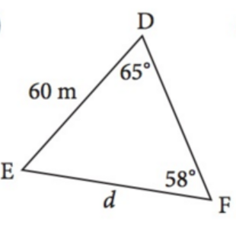
Part A
1. For the given non-right triangle, write the Sine Law equation that would allow you to solve for side d.

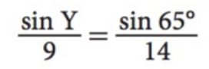
2. For the given Sine Law equation, sketch a labeled diagram of its corresponding triangle, XYZ.

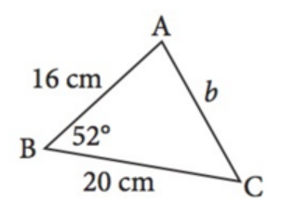
3. Examine the triangle below. Would you use the Sine Law to solve for the indicated side? Explain why or why not.

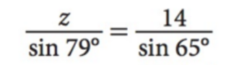
4. Solve the following Sine Law equation for z. Round the side length to the nearest unit.

5. Solve the following Sine Law equation for angle Y. Round your answer to the nearest degree.

Part B
Solve the following problem.
Problem
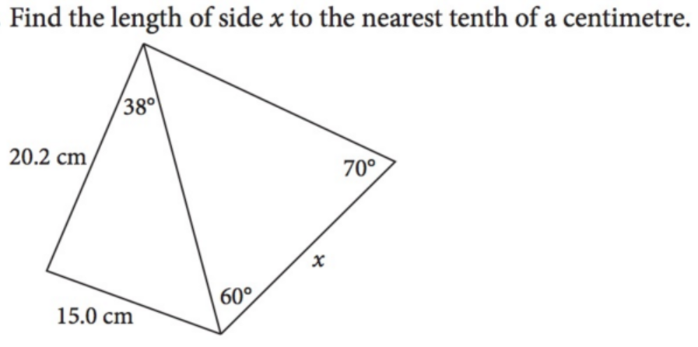
50⁰
Hint: Start by working with the triangle on the left.
56⁰

