MBF 3C Quiz: S=O/H, C=A/H, T=O/A
Name: _____________________ Date: ______________

Course expectation you’re working on…
____ Students will solve problems, including those that arise from real-world applications (e.g., surveying, navigation), by determining the measures of the sides and angles of right triangles using the primary trigonometric ratios.

- Answer each of the following on the quiz paper in the spaces provided.
- Show each of the steps in your thinking process.
- Make sure that your calculator is in DEG (or D) mode!

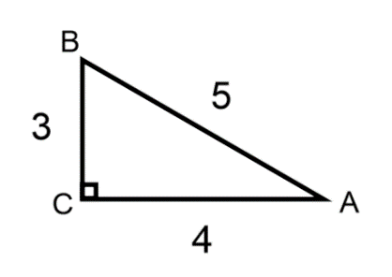
1. Using angle A as your reference angle, label the opp, adj and hyp.
2. The sin ratio for angle A in the above triangle can be written as$sinA=\frac{3}{5}$.
Write the cosine and tangent ratios for angle A.
a) cos A = b) tan A =

3. Use one of the inverse trig ratios (sin⁻¹, cos⁻¹, or tan⁻¹) and its corresponding ratio in #2 to find the measure of angle A. Round angle A to the nearest degree.

4. Determine the measure of the remaining angle in the given triangle—angle B.

5. Consider the following scenario.
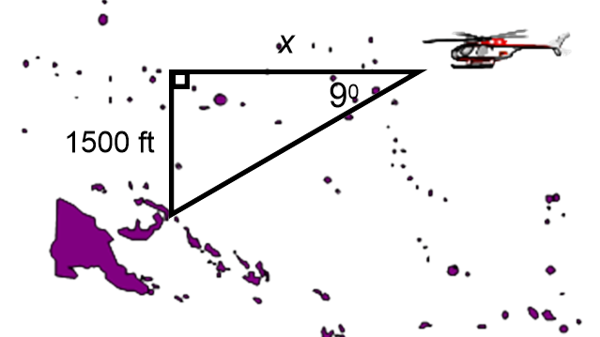
A rescue helicopter is flying horizontally at an altitude of 1500 feet over Georgian Bay toward Beau-soleil Island. The angle between the horizontal and the island is 9⁰.
a) What trig ratio (sin, cos, or tan) would you use to determine how much farther the helicopter must fly before it is above the island? _______
Clearly explain your choice.

( Over )

b) Calculate this distance (i.e., the horizontal distance) using the trig ratio you’ve chosen in a). Round your answer to the nearest foot.

_____________________________________________________________________________________________
For ‘Office’ Use Only

